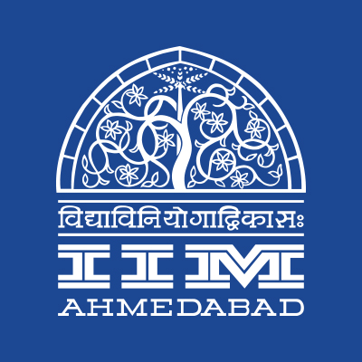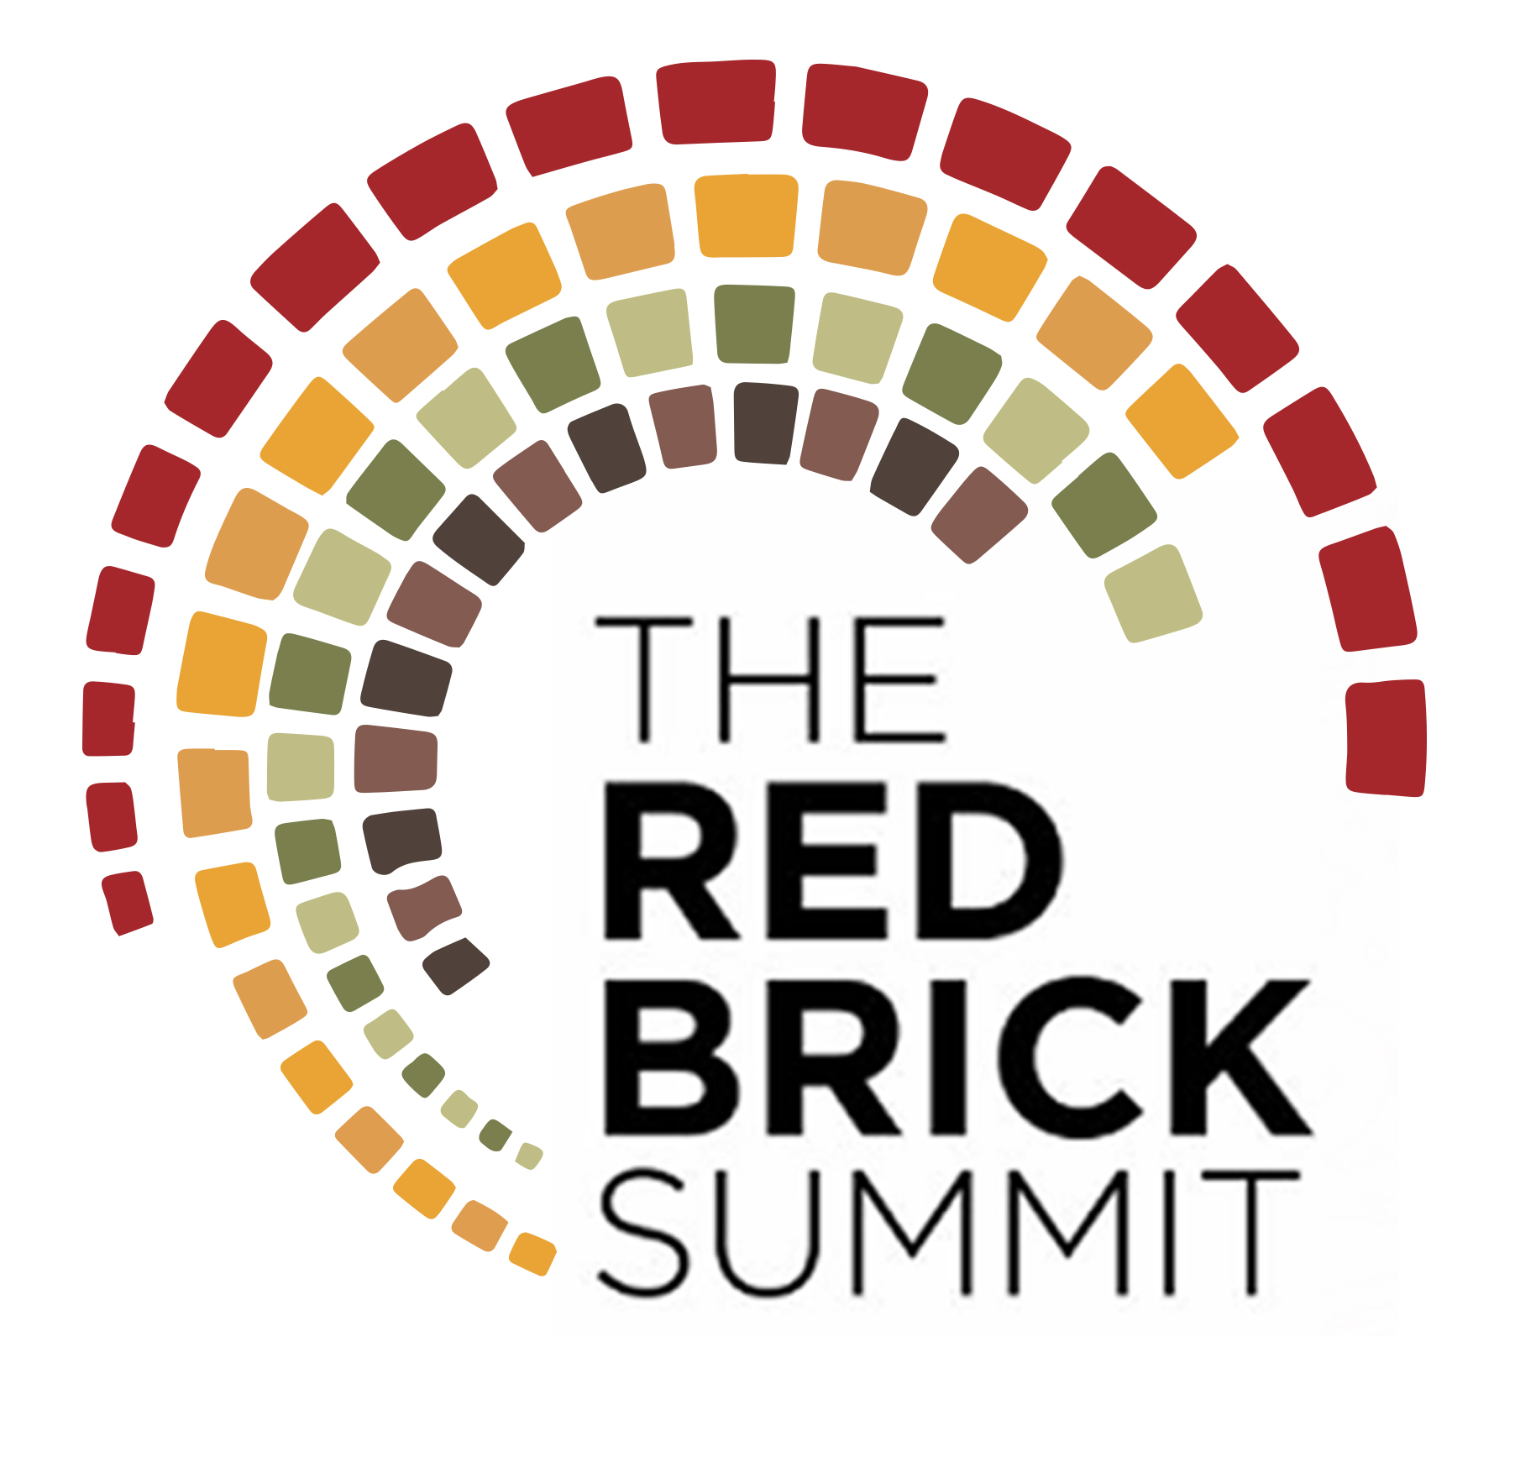

PRESS RELEASE
The Red Brick Summit: The Management Powerhouse at IIMA
Introducing the management fest of IIMA
July 22, 2017 | Ahmedabad
The Indian Institute of Management, Ahmedabad is all set to host its biggest management symposium to date - in the latter half of 2017. Appropriately named the Red Brick Summit, after the famous environs that have come to be associated with over 50 years of academic excellence, the fest will be an amalgamation of the erstwhile Big Three of IIMA; Insight, Confluence and Amaethon.
This transformation has been brought with the strong belief that it shall set the stage for a business ecosystem comprising of the strengths of the three independent mega events while leveraging on the synergies that such a union would bring about.
The fest is to be held in late September from 29th September 2017 to 2nd October 2017 and shall witness the stalwarts from the top echelons of the business world coming to the campus amidst an expected footfall of over 20,000 to give their insights and put their thoughts on the various facets of the business world today.
The fest would comprise of 16 events, 12 workshops and 8 speaker sessions over 4 days spanning across 8 conclaves namely, Entrepreneurship and Innovation; Marketing and Strategy; Finance and Technology; Sports, Media and Entertainment; Operations and Human Resources; Public Policy and Economics; Arts and Social; and Agriculture and Food.
The fest is expected to receive over 32,000 registrations and host students from over 200 national and international institutes over the 4 day period which would include participants and attendees for the workshops and speaker sessions.
TRBS is striving to depart from the norms of the management fests held so far by inviting international participation, academia and corporates to be a part of this summit so as to enhance the knowledge exchange and help us carry forward the spirit of global businesses.
What the IIMA faculty members have to say about TRBS:
"The Red Brick Summit has been designed to provide a comprehensive exposure to management students. The Summit will provide a platform for participants to interact and learn from each other, as well as from domain experts from the industry. Competitions such as Master Plan will help students from across the world to test their skills in preparing business plans and designing successful business models. There will also be special workshops that enable participants to learn and develop new skills from the finest minds. We are looking forward to welcome enthusiastic participants from across the globe for 4 days of learning and fun."
-Prof. Amit Karna, Professor, IIMA
“Management is among the more applied of all higher education faculties. It is not surprising that student festivals in management schools naturally stand out as the high point of academic training. The Red Brick Summit at IIM-Ahmedabad, in this refreshing new format, builds on the institute's legacy of running highly acclaimed management festivals. With a renewed focus, the summit develops synergies between different management functions and aims to foster interdisciplinary dialogue. We enthusiastically welcome students from across the globe for the summit; we invite them to turn the campus into a sandbox of active learning, experimentation, and a splashing cauldron of engaging activities.”
-Prof. Anish Sugathan, Professor, IIMA
Team TRBS speaks:
“TRBS promises to be a one-stop location to get a 360-degree overview of management. We have power packed the four days with some exciting do-it-yourself workshops, business competitions and sessions by some eminent speakers. Live management, the IIM Ahmedabad way, only at The Red Brick Summit, from Sep 29 to Oct 2, 2017.”
-Shrey Jain, Secretary, TRBS

“The Red Brick Summit is THE event to attend if you have the desire to compete with the best and learn from the masters of the management fields.”
-Abhishek Aggarwal, Marketing & PR Manager, TRBS
“Have the hunger to learn the newest ways of management, to understand the innovations in the domains of business? Then TRBS is the event for you!”
-Varun Joshi, Marketing & PR Manager, TRBS
-End of Text-

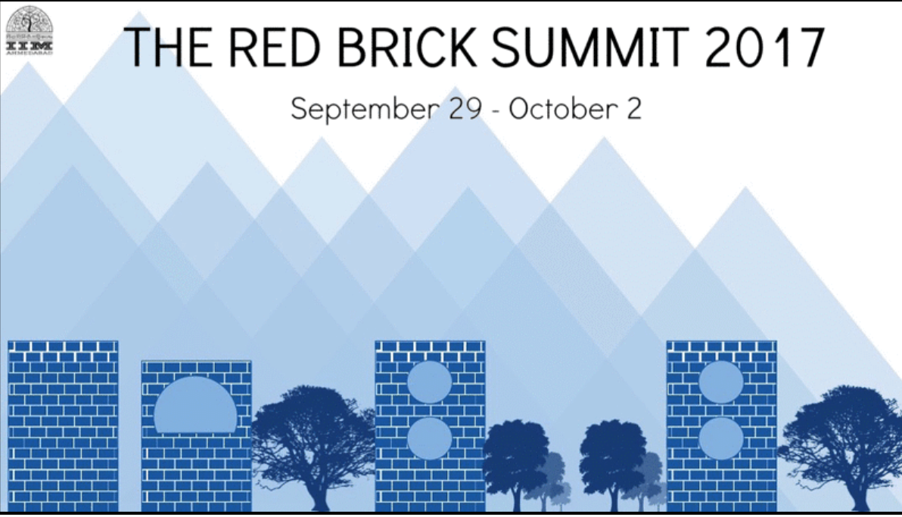

About Indian Institute of Management Ahmedabad (IIMA)
Established in 1961, the Indian Institute of Management, Ahmedabad (IIMA) is recognized globally for excellence in management education. One of the top management schools in the world, IIMA educates leaders of the enterprises.

The Institute’s strategic priorities include: strengthening connection with its various constituencies, including academics, practitioners, alumni, and the community; nurturing a high performance work environment of stretch, autonomy, and teamwork; and strategic growth while maintaining emphasis on quality.

As per the latest ranking by The Economist, IIMA is No. 1 School in the world on the parameter of opening up new career opportunities for students. The flagship Post Graduate Programme (PGP) is ranked 16th in the Financial Times Masters in Management Ranking 2016. As per the Financial Times’ Global MBA Ranking 2016, IIMA’s Post Graduate Programme for Executives (PGPX) is ranked 24th in the World. IIMA has been ranked as #1 Management institute as per the National Institutional Ranking Framework (NIRF) rankings of Ministry of Human Resource Development, Government of India.

For media queries, please contact:

Abhishek Agarwal  PR & Media Relations, TRBS  Ph: (Cell) +91-9999066979  Mail: p16abhishek16@iima.ac.in | Varun Joshi  PR & Media Relations, TRBS  Ph: (Cell) +91-8410464140  Mail: p16varunj@iima.ac.in | Arpit Jain  External Media Relations  Ph: (Cell) +91-9916288168  Mail: p16arpitj@iima.ac.in

