PRESS RELEASE

Creative & Cultural Businesses Programme culminates with a panel discussion on ‘Global economic value of Indianness’ at IIMA

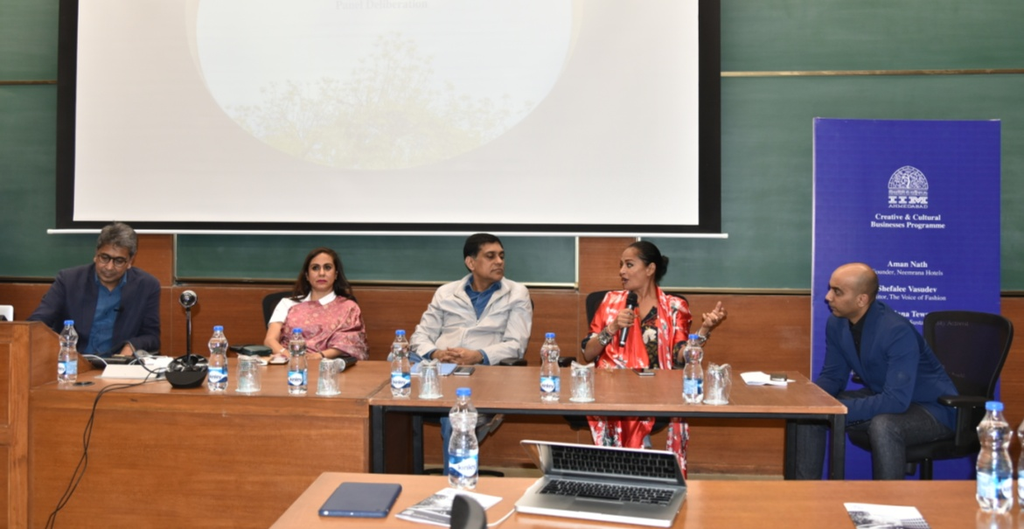
(l-r) Mr. Anchal Jain, Co-Chair, Creative & Cultural Businesses Programme at IIMA; Ms. Shefalee Vasudev, Editor, The Voice of Fashion; Mr. Hari Nair, Founder, HolidayIQ; Ms. Bandana Tewari, Fashion Journalist & Sustainability Activist and Richard Mascarenhas, Head, Video Content Business, Sony Music

January 30, 2019 | Ahmedabad

Creative & Cultural Businesses Programme (CCBP) at IIM Ahmedabad culminated on January 29, 2019 with a Launch Pad event, showcasing the outcomes of the graduating cohort - the journeys of 30 creative entrepreneurs, handloom weavers and artisans.

Prof. Amit Karna, Co-Chair, CCBP at IIMA said, “The Creative and Cultural Businesses Programme is an effort by IIMA to nourish and strengthen the ecosystem in the sector that has the potential to provide livelihood to millions of artisans and craftspeople across the country. We hope that the young entrepreneurs from this programme will spread their wings to not only create interesting ventures, but also take the message of Indianness to the local market and the world.”

To which, Mr. Anchal Jain, Co-Chair, CCBP, IIMA also added, “It is both heartwarming and deeply satisfying to see the distance the cohort has covered in terms of applying their learnings in turning their ideas into marketable business ventures in a space of six months.”

The valedictory ceremony this year was marked with a meaningful deliberation on one of the programme’s fundamental convictions, Indianness.

It was carefully chosen to signify the importance of bringing our unique Indianness to the world.

The Deliberation subject was, ‘Global economic value of Indianness'. It explored our soft cultural power as a vital influencer in building sustainable global brands. This soft influence is a unique scent of each nation, paving way for people to assign more value to its products and services. The panel deliberated different aspects of this power with the outcomes helping the creative and cultural entrepreneurs in better shaping their offerings.

The panel assembled was most fitting and excited to deliberate this relevant topic that has a crucial role in determining what is next for the Indian creative economy.

Mr. Aman Nath, Historian and Founder of 'Neemrana Hotels'
Ms. Shefalee Vasudev, Editor, The Voice of Fashion
Ms. Bandana Tewari, Lifestyle Journalist and Sustainability Activist
Mr. Hari Nair, Founder of HolidayIQ
Mr. Richard Mascarenhas, Video Content Business, Sony Music Entertainment

One of the panelists, Ms.Bandana Tewari, lifestyle journalist and sustainability activist said, “The LaunchPad at CCBP was a wonderful reminder how enriching and inspiring it is when institutions teach students to cross-pollinate creative bravado with sound business acumen.”

Some of the dimensions deliberated were:

-The voice of Indianness and its role in the contemporary world; how can the Indian diaspora amplify it.
-A visual narrative of where that voice is today globally and where it can go
-The role of the tourism industry in building perspectives of Indianness
-The millenial generation is bringing about the birth of a new, unique musical expression which is influencing other lifestyle domains
- The value of people, human hands, handloom workers, the economic potential of India’s crafts and cultural industries

One of the course participants, Ms. Pooja Shirali, Founder, Mirrah, said, “It was a great platform and opportunity to present in front of such a distinguished audience that included industry experts and investors. A perfect end to the great learning journey that was in the last 6 months. The opportunity to present and showcase our idea was exciting but the real takeaway was the valuable inputs, appreciation and feedback that I received yesterday.”

The audience also had a chance to engage with the passion, conviction and readiness of the 30 participants through a physical showcase of their project ideas.

-----------------------------------------------------------------------------------------------

More about:
Creative and Cultural Businesses Programme (CCBP) at Indian Institute of Management Ahmedabad(IIMA) is a one-of-a-kind executive education programme for entrepreneurs in creative and cultural industries. It is designed for the participants to understand the deep nuances of this industry in order to build meaningful ventures at a global scale. It's four core pillars are: 1) True meaning of luxury. 2) Conscious and inclusive businesses. 3) Unique Indianness with global relevance. 4) Value of Indian artisanal arts and crafts heritage. Professors, industry experts, contemporary thought leaders, artisans and new generation of entrepreneurs come together in a dynamic environment questioning and learning what India’s creative economy can offer to the world.

The participants come from diverse sectors like Fashion, Textiles, Accessories, Ceramics, Glass printing, Architecture & Interiors, Furniture, Art Gallery, Art Tours, Performing Arts, Food & Beverage, Hospitality, Health & Wellness including artisans such as handloom weavers and natural dyers.

More information at: www.ccbp.ciie.co
Reach us at: ccbp@iima.ac.in

